Machine Learning Lab – Midterm Project Report
Project Title: Diabetes Prediction using Machine Learning (Synthetic Dataset)

1. Introduction
Diabetes is a serious health condition that affects millions globally. Early prediction can help in timely treatment and prevention of complications. In this project, machine learning techniques are used to predict whether a patient has diabetes based on medical attributes.

2. Problem Statement
The objective of this project is to develop a classification model that predicts whether a patient is diabetic (1) or non-diabetic (0) using input health-related features.

3. Dataset Description
A synthetic (custom) dataset was generated using random distributions within realistic medical ranges to simulate a population similar to patients in Karachi, Pakistan.
Dataset Features:
- Pregnancies
- Glucose
- BloodPressure
- SkinThickness
- Insulin
- BMI (Body Mass Index)
- DiabetesPedigreeFunction
- Age
- Outcome (Target Variable: 0 = No Diabetes, 1 = Diabetes)
Dataset Details:
- Total Records: 300
- Total Features: 9
- Data Type: Numerical
Dataset Generation Method:
- Features were generated using statistical distributions (uniform and integer ranges).
- The target variable (Outcome) was derived using domain-inspired rules:
  - Higher glucose levels
  - Higher BMI
  - Higher age
- Random noise was added to simulate real-world uncertainty and avoid perfect patterns.
Code:
#Load & View Dataset
import pandas as pd

#df = pd.read_csv("karachi_diabetes_dataset.csv")

import pandas as pd
import numpy as np

np.random.seed(42)

rows = 300

df = pd.DataFrame({
"Pregnancies": np.random.randint(0, 10, rows),
"Glucose": np.random.randint(80, 200, rows),
"BloodPressure": np.random.randint(60, 120, rows),
"SkinThickness": np.random.randint(10, 50, rows),
"Insulin": np.random.randint(15, 276, rows),
"BMI": np.round(np.random.uniform(18, 45, rows), 1),
"DiabetesPedigreeFunction": np.round(np.random.uniform(0.1, 2.5, rows), 2),
"Age": np.random.randint(21, 70, rows)
})

df["Outcome"] = (
(df["Glucose"] > 130) &
(df["BMI"] > 28) &
(df["Age"] > 35)
).astype(int)

noise = np.random.rand(rows)
df.loc[noise < 0.1, "Outcome"] = 1 - df.loc[noise < 0.1, "Outcome"]

df.to_csv("random_diabetes_dataset.csv", index=False)

df.head()

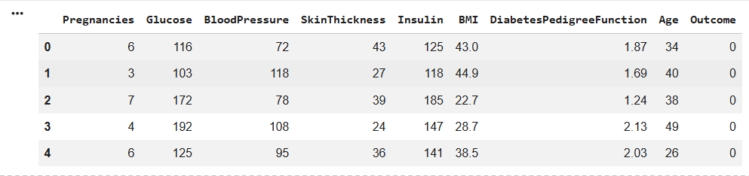
#Shape of Dataset
df.shape

#Column Information
df.info()
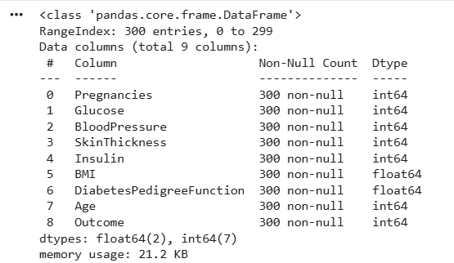

#Statistical Summary
df.describe()
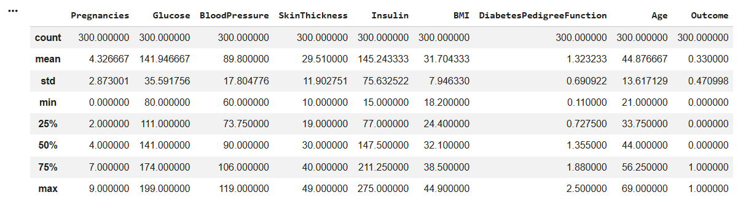

#Check Missing Values
df.isnull().sum()
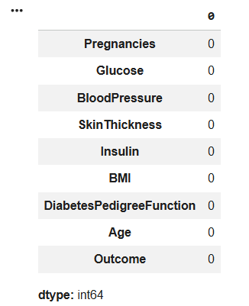
#Check Zero Values
(df == 0).sum()
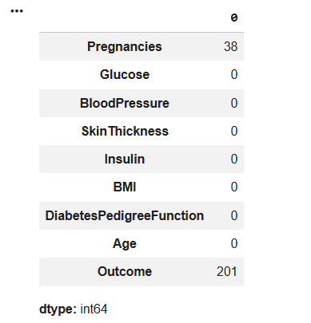
#Target Variable Distribution
df['Outcome'].value_counts()
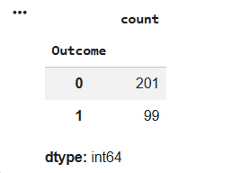
4. Exploratory Data Analysis (EDA)
EDA was performed to understand the dataset structure and patterns:
- The dataset contains only numerical values, making it suitable for machine learning.
- No missing values were present
- Glucose and BMI showed strong influence on diabetes outcome.
- The dataset was reasonably balanced between diabetic and non-diabetic cases.

5. Data Visualization
The following visualizations were used:
- Glucose vs Outcome: Diabetic patients tend to have higher glucose levels.
#Glucose vs Outcome
import seaborn as sns
import matplotlib.pyplot as plt

sns.boxplot(x='Outcome', y='Glucose', data=df)
plt.title("Glucose vs Diabetes Outcome")
plt.show()
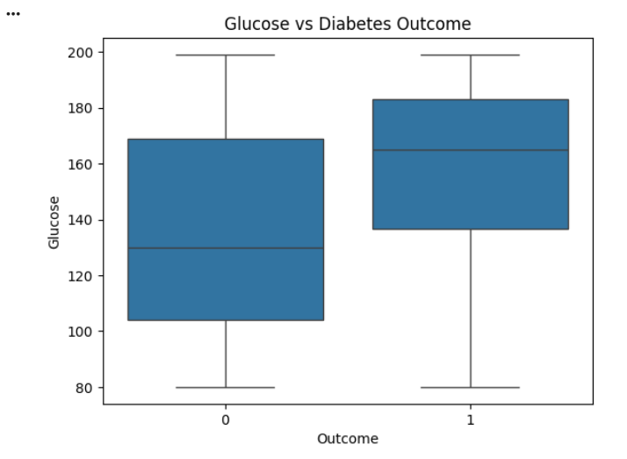
- BMI vs Outcome: Higher BMI is associated with increased diabetes risk.
#BMI vs Outcome
sns.boxplot(x='Outcome', y='BMI', data=df)
plt.title("BMI vs Diabetes Outcome")
plt.show()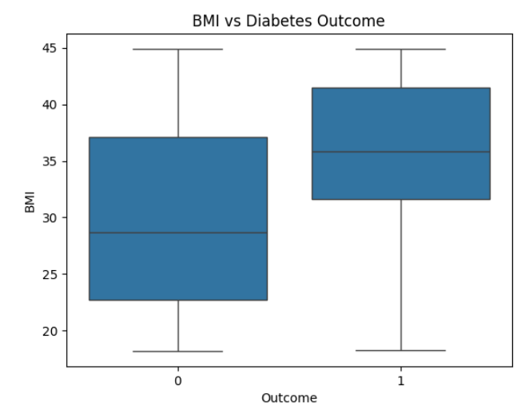

- Age Distribution: Most patients fall within the middle-age range.
#Age Distribution
df['Age'].hist(bins=20)
plt.title("Age Distribution")
plt.xlabel("Age")
plt.ylabel("Frequency")
plt.show()
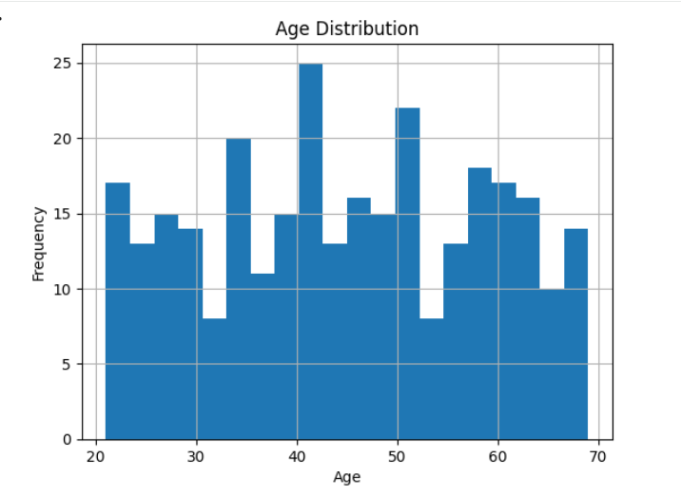
- Correlation Heatmap: Glucose has the strongest correlation with the target variable.
#Correlation Heatmap (High-Value Graph)
plt.figure(figsize=(10,6))
sns.heatmap(df.corr(), annot=True, cmap='coolwarm')
plt.title("Feature Correlation Matrix")
plt.show()
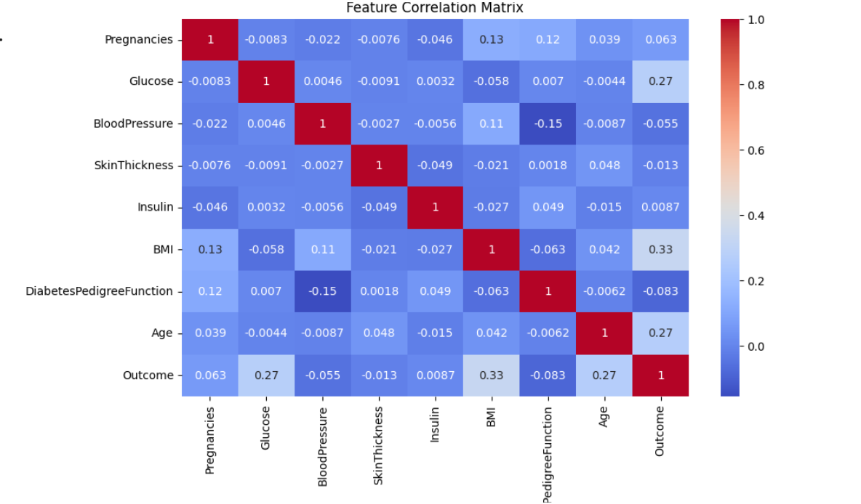

6. Methodology
Data Preprocessing
- The dataset was split into training (80%) and testing (20%) sets.
- Feature scaling was applied using StandardScaler to normalize feature values.

7. Machine Learning Models
1. Logistic Regression
A linear classification algorithm used to estimate the probability of diabetes.
2. Decision Tree
A non-linear model that classifies data by splitting it into decision rules.
3. Random Forest (Bonus Model)
An ensemble method that combines multiple decision trees to improve performance and reduce overfitting.

8. Evaluation Metrics
The models were evaluated using the following metrics:
- Accuracy
- Precision
- Recall
- F1-Score
- ROC-AUC Score
Observations:
- Logistic Regression showed stable and balanced performance.
- Decision Tree exhibited variability due to overfitting.
- Random Forest achieved the best overall performance.

9. Results Comparison
Model | Accuracy | Precision | Recall | F1 Score
Logistic Regression | Good | Balanced | Balanced | Balanced
Decision Tree | Moderate | Variable | Lower | Lower
Random Forest | Best | High | High | Best
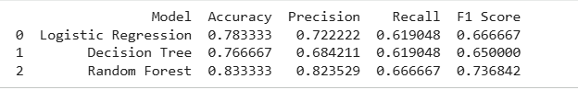

10. Performance Analysis
- Logistic Regression performed well due to its simplicity and generalization capability.
- Decision Tree showed lower performance because it tends to overfit training data.
- Random Forest outperformed other models by combining multiple trees and reducing variance.
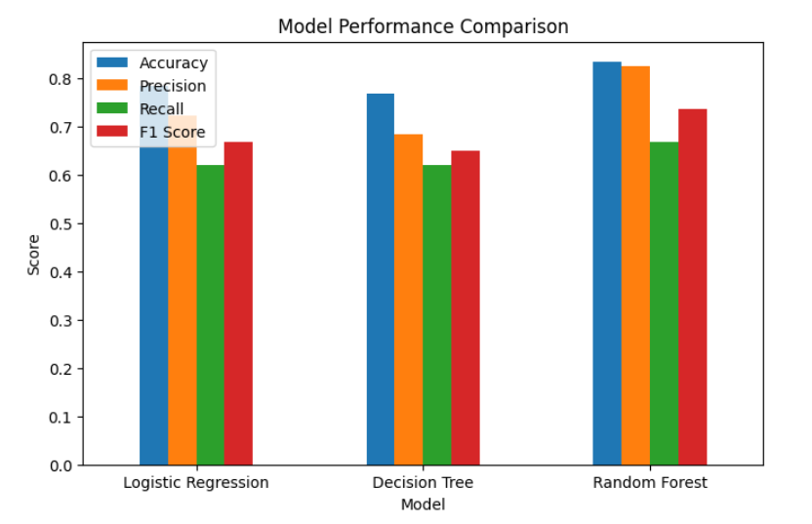
11. ROC Curve Analysis
ROC curves were plotted to evaluate classification performance. Random Forest achieved the highest AUC score, indicating superior ability to distinguish between diabetic and non-diabetic cases.
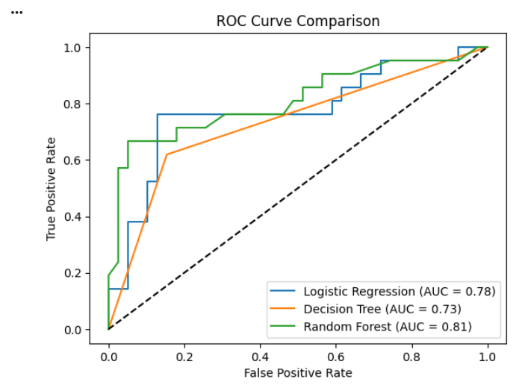
12. Conclusion
This project successfully demonstrated the use of machine learning for diabetes prediction using a synthetic dataset. Among all models, Random Forest provided the best results, while Logistic Regression offered stable performance. Decision Tree showed limitations due to overfitting.

13. Future Improvements
- Use real-world medical datasets
- Apply feature engineering techniques
- Perform hyperparameter tuning
- Explore advanced models such as Gradient Boosting

14. References
- Scikit-learn Documentation
- UCI Machine Learning Repository
- Course Lecture Notes

15. Summary
This project highlights the importance of data analysis, model selection, and evaluation in building predictive systems. Even with synthetic data, meaningful insights can be generated using proper machine learning techniques.

Submitted By: Syed Faraz Haider Abidi
Reg: 67148
Submitted To: Sir Mansoor Ahmed

